Planning for CBID Training

As part of the preparation for training, it is important to identify the institutions, organizations, and individuals that can help the training team, to bring to life the subjects covered.

It is also important to be creative in planning the training. Using the CBR Matrix as a guide, identify a local lead contact person to compile information on the different stakeholders working in each area of the CBR Matrix using the table below. Districts may have different institutions and services: for example, a Village Savings and Loans scheme, a branch of PODCAM, a rehabilitation centre, a DPO, an inclusive school, or disability inclusive sports clubs. Different districts may also have different disability activists and role models.

Information collected will be useful for a variety of purposes including those listed below:

- To identify suitably qualified persons to be involved as trainers or co trainers
- To identify participants for the training
- To identify available services and structures and existing gaps to make reference to during the training
- To identify institutions and/or individuals for field visits e.g. as part of training for the management of specific disabilities
- To identify guest speakers and other persons with disabilities that could provide lived experiences
- To use examples of good practice to include in different sessions
- To provide information which could be used to adapt or combine training sessions. For example, a visit to an inclusive school could be used to meet a variety of children with different disabilities as one of the Management of specific disabilities sessions, and could include a presentation by a teacher on Community mobilization. Similarly, a visit to a MAP orthopaedic workshop could be used to cover the Assistive Devices session as well as one of the Management of specific disabilities sessions. Further, a visit to a rehabilitation centre could be used to cover Rehabilitation and Referrals and visit to a Parent Support Group could cover the Parent Support Group session as well as Lobbying and Advocacy.
- Use information provided to inform planning for other sessions e.g. Session on Stakeholder mapping as well as to promote networking and collaboration.

Complete the form below with the information gathered, and discuss this at your initial training planning meeting, which you should hold at least one month ahead of the training delivery.

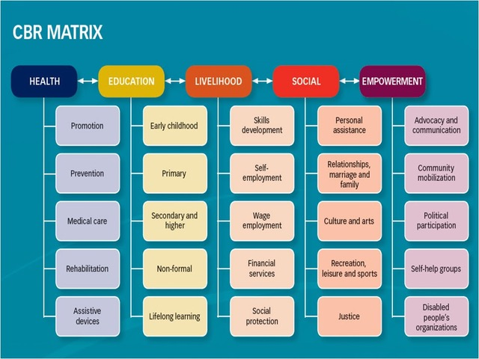

Complete the following table with information on organizations, institutions, or individuals that are working in each area of the CBR Matrix in the District, and complete the last section with information on organizations working on cross cutting issues or other areas.

Health | Organization/Institution/Individual | Brief information on their work / role
Promotion
Prevention

Medical care
Rehabilitation
Assistive devices
Education | Organization/Institution/Individual | Brief information on their work / role
Early childhood
Primary
Secondary and higher

Non-formal
Lifelong learning
Livelihood | Organization/Institution/Individual | Brief information on their work / role
Skills development
Self-employment
Wage employment

Financial services
Social protection
Social | Organization/Institution/Individual | Brief information on their work / role
Personal assistance
Relationships, marriage and family
Culture and arts

Recreation, leisure and sports
Justice
Empowerment | Organization/Institution/Individual | Brief information on their work / role
Advocacy and communication
Community mobilization
Political participation

Self-help groups
Disabled people’s organizations
Cross-cutting issues: | Organization/Institution/Individual | Brief information on their work / role
Gender
HIV and AIDS
Disaster risk reduction and relief activities

Children
Other (please state)
Other (please state)
Other (please state)

